***STAT 6300 Final Project Report:***

***Multivariate Analysis for the Personality Investigation***

Professor name: Dr. Nancy S. Boudreau

Student name: Siliang Zhao

Date: Dec. 08.2013

**TABLE OF CONTENTS**

1. Introduction 3

2. Data collection 3

3. Methodology 3

3.1 Model 3

3.2 Sum of Square 3

3.3 Test Statistics 4

4. aNALYSIS AND RESULTS 4

4.1 Normality Checking 5

4.2 Two-way MANOVA including interaction term 6

4.3 Two-way MANOVA excluding interaction term 7

4.4 One-way MANOVA 8

4.4.1 Multinomial Test 8

4.4.2 Univariate Test 9

4.5 Factor Analysis 11

5. ConCLUSION AND RECOMMENDATION 12

Appendix 1: Questionnaire 13

**1. Introduction**

Personality refers to individual differences in characteristic patterns of thinking, feeling and behaving. A good personality will help people have comfortable relationships with others and will surely help people in the career development as well. Will the life experiences eventually change personality? Therefore, we are going to investigate whether gender and age, which we have divided into 4 different age groups, under 30, 30-40, 40-50, 50 and above, have significant impact on different aspects of personality, such as social dominance, sociability, stress reaction, worry scale, impulsivity, thrill-seeking. Also, for the six variables, we want to investigate whether they have similar properties that could make us to group them together as one or several factors.

**2. Data collection:**

As required, we use the secondary source of data, which named “interest”, collected from the website <http://psych.colorado.edu/~carey/Courses/PSYC7291/ClassDataSets.htm>. The website is a psychological course in University of Colorado. The data is designed primarily for multiple regression and SEM, however, we will use other methods to analyze partial data (including age, gender, social dominance, sociability, stress reaction, worry scale, impulsivity, and thrill-seeking) instead the two methods mentioned above.

**3. Methodology:**

We will use Multivariate Two-way MANOVA, one-way MANOVA and one-way ANOVOA and factor analysis to investigate whether factor gender and age will have significant impact on personality.

3.1 Model:

$y_{ijk}=μ+α_{i}+β_{j}+{{αβ}_{ij}+ε}_{ijk}$ $i=1,2$ $j=1,2,3,4$ $k=1,2,3,4,5,6$

$α_{i}:effect of ith level of Factor A gender on the overall mean vector$

$β_{j}:effect of jth level of Factor B age on the overall mean vector$

$${αβ}_{ij}:effect of the ith level of Factor A gender and the jth level of factor B age on the$$

$overall mean vecter.$

Constaint: $\sum_{i}{α_{i}}$ = $\sum_{j}{β_{j}}$ = $\sum_{i}{{αβ}_{ij}}$ = $\sum_{j}{{αβ}_{ij}}$ =0; Assume ~

3. 2 Sum of Square

|  |  |  |  |
| --- | --- | --- | --- |
| *Source of variation* | *df* | SS + Product Matrices | *Test Statistics* |
| A | *a-*1 | **H**A = |  |
| B | *b-*1 | **H**B = |  |
| AB | (*a-*1)(*b-*1) | **H**AB = |  |
| Error | *ab*(*n-*1) | **E** = |  |
| Total | *abn*-1 | **T** = |  |

3.3 Test Statistic

${}_{A}$ = $\frac{|E|}{|H_{A}+E|}$ ~ ${}_{P, a-1, ab(n-1)}$; ${}_{B}$ = $\frac{|E|}{|H_{B}+E|}$ ~ ${}_{P, b-1, ab(n-1)}$; ${}_{AB}$ = $\frac{|E|}{|H_{AB}+E|}$ ~ ${}_{P,(a-1)( b-1), ab(n-1)}$

**4. Analysis and result**

For our case, this 2-way MANOVA has 2 factors and 6 dependent variables:

Factor A—Gender--- 2 levels: 1= male, 2= female;

Factor B---Age--- 4 levels: 1= age<30; 2=30 $≤age<40$; 3=40 $≤age<50$; 4= 50 $≤age$

6 dependent variables:

y1= personality: social dominance---socdom y2= personality: sociability---sociabty

y3= personality: stress reaction---stress y4= personality: worry scale---worry

y5=personality: impulsivity---impulsve y6= personality: thrill-seeking---thrillsk

Assume: $ε_{ijk}$ ~ $N_{p}(0, Σ)$

4.1 Normality Checking

Multivariate Normality:

$H_{0}:$ The data are multivariate Normal vs $H_{1}:$ The data are not multivariate Normal

In this case, we assume $Σ_{1}=Σ_{2}=Σ_{3}=Σ_{4}$**.**

For Group 1: For Group 2:

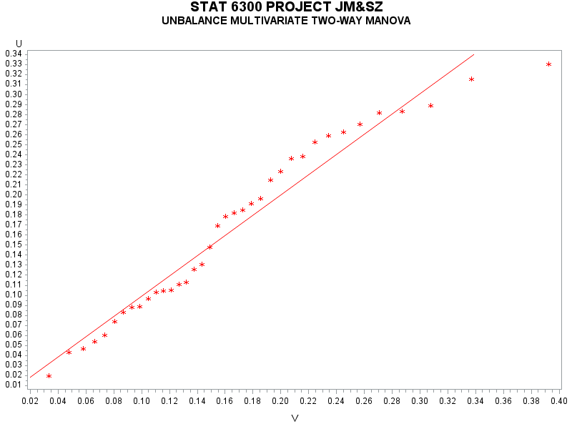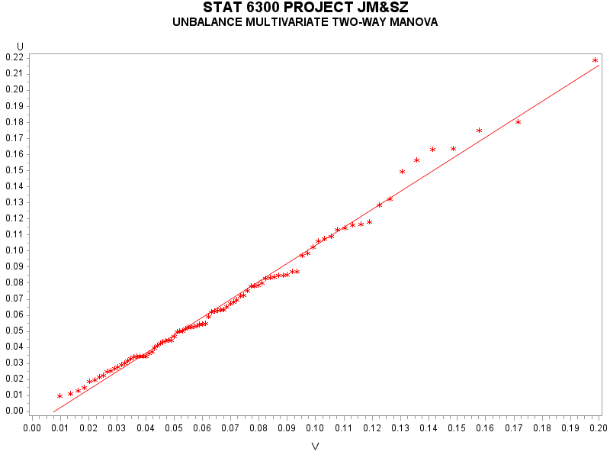

For Group 3 For Group 4:

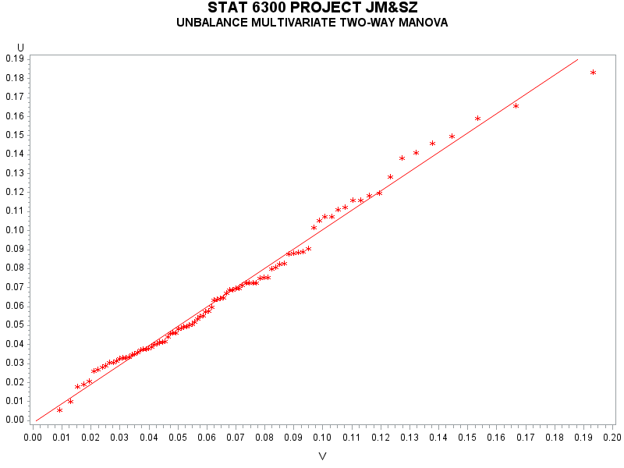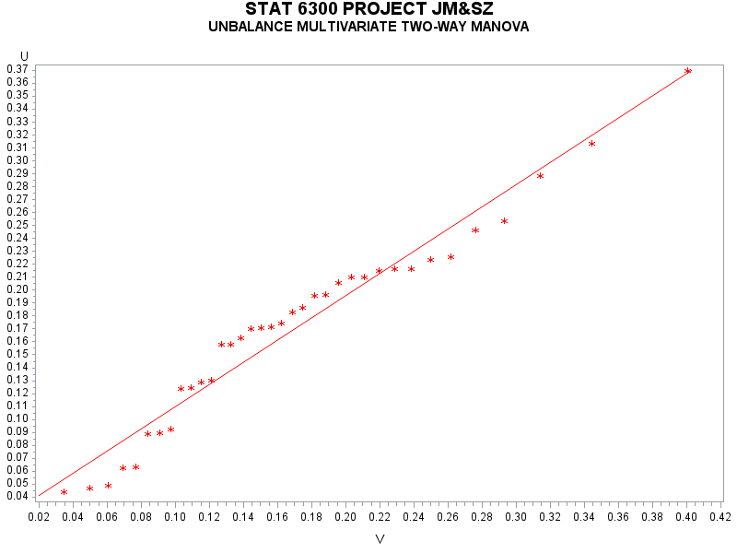

|  |  |  |
| --- | --- | --- |
| Group | T.S. | R.R. |
| age<30 | 11.5839 | Reject $H_{0}$ if $D_{i}^{2}$ > 23.094 |
| 30 $≤$ age<40 | 18.6273 | Reject $H_{0}$ if $D_{i}^{2}$ > 19.197 |
| 40 $≤$ age<50 | 16.1424 | Reject $H_{0}$ if $D_{i}^{2}$ > 19.197 |
| age $≥$ 50 | 12.5785 | Reject $H_{0}$ if $D_{i}^{2}$ > 23.094 |

Conclusion:

With $p=6,n_{1}=37$ and $α=0.01$, the critical value is $23.094$. Since the max $D_{i}^{2}=11.5839<23.094$, there is sufficient evidence that the data for group 1 (age<30) are multivariate normal.

With $p=6,n_{1}=87$ and $α=0.01$, the critical value is $23.094$. Since the max $D_{i}^{2}=18.6273<19.197$, there is sufficient evidence that the data for group 2 (30 $≤$ age<40) are multivariate normal.

With $p=6,n_{1}=90$ and $α=0.01$, the critical value is $23.094$. Since the max $D_{i}^{2}=16.1424<19.197$, there is sufficient evidence that the data for group 3 (40 $≤$ age<50) are multivariate normal.

With $p=6,n_{1}=36$ and $α=0.01$, the critical value is $23.094$. Since the max $D_{i}^{2}=12.5785<23.094$, there is sufficient evidence that the data for group 4 (age $≥$ 50) are multivariate normal.

Since the data for each group is multivariate normal, we do not need to check normality for individual variable within each group.

4.2 Two-way MANOVA including interaction term

First, we decide to analysis the data set with model

$y_{ijk}=μ+α_{i}+β_{j}+{{αβ}_{ij}+ε}_{ijk}$ $i=1,2$ $j=1,2,3,4$ $k=1,2,3,4,5,6$

Based on our analysis and SAS output, we have the following result of E matrix and H matrix:

E matrix: Appendix table1 E matrix

H matrix for A—gender: Appendix table 2 H matrix

H matrix for A—age group: Appendix table 3 H matrix

H matrix for interaction AB—gender*age group: Appendix table 4 H matrix

Test for presence of interaction AB—gender*age group:

Ho: ${αβ}_{ij}=0 for all i and j, i=1,2;j=1,2,3,4$

Ha: at least one ${αβ}_{ij}≠0$: Appendix table 5 E Inverse *H matrix for interaction

Appendix table 6 Exact p-value table for interaction gender*GRP

***Test Statistics:*** F=0.98 , p-value=0.4883,

***Decision rule:*** if p-value < $α=0.05$, reject null hypothesis.

***Conclusion:*** Since p-value of multivariate approach for gender*age is 0.4883 (Pillai’s Trace), which is greater than $α=0.05$, we **do not** have sufficient evidence at 95% confidence level to reject null hypothesis. Hence we conclude that no interaction between gender and age for this 2-way MANOVA.

Since interaction of AB---gender*age is not significant, we continue our analysis on main effect tests:

For factor A---gender:

Ho: $α_{i}=0$

Ha: $At least 1 α_{i}≠0$

Appendix table 7 E Inverse *H matrix for gender and Exact p-value table for gender

***Test Statistics:*** F=1.56 , p-value=0.1583,

***Decision rule:*** if p-value < $α=0.05$, reject null hypothesis.

***Conclusion:*** Since p-value of multivariate approach for gender is 0.1583 (Roy’s Greatest Root), which is greater than $α=0.05$, we **do not** have sufficient evidence at 95% confidence level to reject null hypothesis. Hence we conclude that no difference in two mean vectors between two genders: male vs. female.

For factor B---age:

Ho: $β_{j}=0$

Ha: $At least 1 β_{j}≠0$

Appendix table 8 E Inverse *H matrix for GRP

Appendix table 9 Exact p-value table for GRP

***Test Statistics:*** F=1.60 , p-value=0.0525,

***Decision rule:*** if p-value < $α=0.05$, reject null hypothesis.

***Conclusion:*** Since p-value of multivariate approach for age is 0.0491 (Wilks’ Lambda), we have sufficient evidence at 95% confidence level to reject null hypothesis. Hence we conclude that there is significant difference among the four age groups.

4.3 Two-way MANOVA excluding interaction term

Since our case is an unbalance case and the interaction term of AB(gender*age) is not significant in multivariate case, we will continue to explore whether the main effect will become significant after excluding the interaction term.

For factor A---gender:

Ho: $α_{i}=0$

Ha: $At least 1 α_{i}≠0$

Appendix table 10 E Inverse *H matrix for gender and Exact p-value table for gender (excluding interaction)

***Test Statistics:*** F=1.43 , p-value=0.2032,

***Decision rule:*** if p-value < $α=0.05$, reject null hypothesis.

***Conclusion:*** Since p-value of multivariate approach for gender is 0.2032 (Roy’s Greatest Root), which is greater than $α=0.05$, we **do not** have sufficient evidence at 95% confidence level to reject null hypothesis. Hence we conclude that no difference in two mean vectors between two genders: male vs. female. This result is consistent with previous model which include the interaction term.

For factor B---age:

Ho: $β_{j}=0$

Ha: $At least 1 β_{j}≠0$

Appendix table 11E Inverse *H matrix for GRP and Exact p-value table for GRP (excluding interaction)

***Test Statistics:*** F=1.65 , p-value=0.0468,

***Decision rule:*** if p-value < $α=0.05$, reject null hypothesis.

***Conclusion:*** Since p-value of multivariate approach for age is 0.0468 (Philai’s Trace), which is less than $α=0.05$ (for the other three methods, it is less than $α=0.05$), we have sufficient evidence at 95% confidence level to reject null hypothesis. Hence we conclude that personality is significant difference among the four age groups.

Since only factor B age is significant, we will continue our multivariate one-way MANOVA test on age, to see which age group is significant higher than other groups.

4.4 One-way MANOVA

4.4.1 Multivariate Test:

Appendix table 12 E Inverse *H matrix for GRP and Exact p-value table for GRP (One-way)

Since the first two explain 91.71% (=77.86+13.85) of the total sum, that is, the essential dimensionality of the space of the mean vector is 2. Therefore, I will choose Pillai’s Trace as the test statistics.

Assume $y_{ij}\sim N_{6}(μ_{i}, Σ)$, independent and random samples.

$H_{0}: μ_{1}=μ_{2}=μ_{3}=μ_{4}$ vs $H_{α}:$ at least 1 $μ_{i}$ differs

T.S. $V^{(3)}=0.11562365$

R.R. Reject $H_{0}$ if p-value < 0.05.

Conclusion: Reject $H_{0}$ at $α=0.05$. There is sufficient evidence of a difference in mean vector among the 4 groups of age.

After detecting the age(GRP) has significant difference among the 4 groups, we will continue our analysis on the univariate case of 4 groups.

4.4.2 Univariate Test:

For each variable, we test

$H_{0}: μ_{i1}=μ_{i2}=μ_{i3}=μ_{i4}$ vs $H_{α}:$ at least 1 $μ_{ij}$ differs

|  |  |  |  |
| --- | --- | --- | --- |
| Variable | T.S. | R.R. | Decision |
| $y_{1}$ = social dominance | F=3.46, p=0.0171 | Reject if $p<α=0.05$ | Reject $H_{0}$ |
| $y_{2}$ = sociability | F=3.15, p=0.0257 | Reject if $p<α=0.05$ | Reject $H_{0}$ |
| $y_{3}$ = stress reaction | F=0.71, p=0.5445 | Reject if $p<α=0.05$ | Do not Reject $H_{0}$ |
| $y_{4}$ =worry scale | F=0.09, p=0.965 | Reject if $p<α=0.05$ | Do not Reject $H_{0}$ |
| $y_{5}$ = impulsivity | F=3.86, p=0.01 | Reject if $p<α=0.05$ | Reject $H_{0}$ |
| $y_{6}$ =thrill seeking | F=2.37, p=0.0714 | Reject if $p<α=0.05$ | Do not Reject $H_{0}$ |

Conclusion:

There is sufficient evidence of a difference in mean social dominance among 4 groups of age at $α=0.05$. Therefore, we conclude that the 4 age groups has significant difference in variable y1= social dominance.

There is sufficient evidence of a difference in mean sociability among 4 groups of age at $α=0.05$.

Therefore, we conclude that the 4 age groups has significant difference in variable $y_{2}$ = sociability .

There is sufficient evidence of a difference in mean impulsivity among 4 groups of age at $α=0.05$.

Therefore, we conclude that the 4 age groups has significant difference in variable $y_{5}$ = impulsivity. There is insufficient evidence of a difference in mean stress reaction among 4 groups of age at $α=0.05$.

There is insufficient evidence of a difference in mean worry scale among 4 groups of age at $α=0.05$.

There is insufficient evidence of a difference in mean thrill seeking among 4 groups of age at $α=0.05$.

Now, run multiple comparisons (Tukeys) on the mean social dominance, sociability and impulsivity for 4 groups of age.

Appendix table 13 Tukey grouping for Social dominance, Sociability and Impulsivity

Social dominance: age<30 40 $≤$ age<50 30 $≤$ age<40 age $≥$ 50

0.3749 0.1462 0.1228 -0.3447

The mean social dominance for young people (whose age are smaller than 30) is significantly higher than the mean social dominance for older people (whose age are greater than 50). From this result, we can see that younger people are generally more active than older people, especially for this social media prevailed era. Therefore, it is easy to see why younger age people have higher social dominance score than older ones.

Sociability: age<30 40 $≤$ age<50 30 $≤$ age<40 age $≥$ 50

0.3957 0.1204 0.0064 -0.3089

The mean sociability for young people (whose age are smaller than 30) is significantly higher than the mean sociability for older people (whose age are greater than 50). Same reason as the last one, young people has more sociability than older ones.

Impulsivity: age<30 30 $≤$ age<40 40 $≤$ age<50 age $≥$ 50

0.3957 0.1204 0.0064 -0.3089

The mean impulsivity for young people (whose age are smaller than 30) is significantly higher than the mean impulsivity for middle-age people and older people (whose age are greater than 40). For the impulsivity, it is common to interpret that young people are more impulsive in many perspective than matured people.

4.5 Factor analysis

By factor analysis, the result is following:

Appendix table 14 for eigenvalue of the Correlation matrix and Rotated factor pattern

By the SAS output, we can find that there are 3 eigenvalue greater than 1 and by rotated factor pattern, we can put y1= personality: social dominance---socdom and y2= personality: sociability---sociabty into ***factor 1***, put y5=personality: impulsivity---impulsve and y6= personality: thrill-seeking---thrillsk into ***factor 2***, and put y3= personality: stress reaction---stress, y4= personality: worry scale---worry into ***factor 3***.

Also we can get the same result by the scree plot:

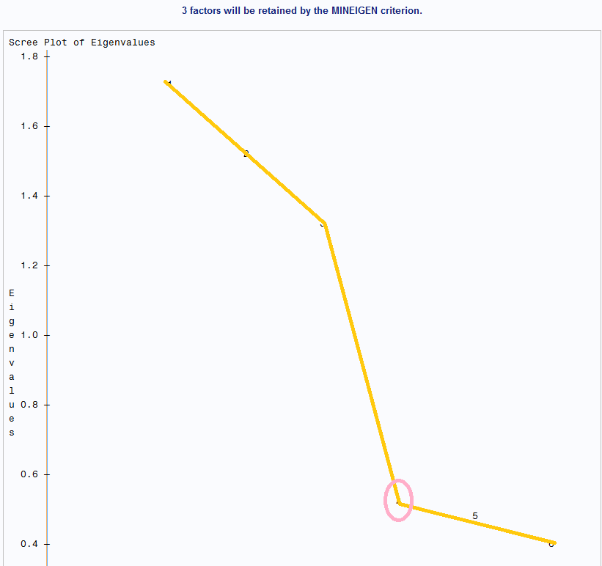

From the scree plot, which based on eigenvalue of S, we can choose m=3 eigenvalues before elbow in plot.

Therefore, we continue analyze the data by using 3 factors. First we will check the correlation between the 3 factors, then check the mean vector by age groups, then test MANOVA by using factors.

Appendix table 15, Pearson Correlation Coefficients and Mean vector of 3 factors by four age groups.

By the above table, we can see that the correlation of factor 1 vs factor 2, factor 1 vs factor 3 and factor 2 vs factor 3 are all equal to 0, which mean they are independent with each other. By the right hand side table, we get the descript statistics of 3 factors by 4 age groups.

One way MANOVA for the factor

Assume $y_{ij}\sim N_{3}(μ_{i}, Σ)$, independent and random samples.

$H_{0}: μ_{1}=μ_{2}=μ_{3}=μ_{4}$ vs $H_{α}:$ at least 1 $μ_{i}$ differs

Appendix table 16 E Inverse *H matrix for GRP and Exact p-value table for GRP (factor analysis)

T.S. $V^{(3)}=0.091$, F=2.57

R.R. Reject $H_{0}$ if p-value < 0.05.

Conclusion: Since all p-value are less than 0.05, we reject $H_{0}$ at $α=0.05$. we have sufficient evidence of a difference in mean vector of factors among the 4 groups of age.

One-way Univariate Test:

For each variable, we test $H_{0}: μ_{i1}=μ_{i2}=μ_{i3}=μ_{i4}$ vs $H_{α}:$ at least 1 $μ_{ij}$ differs

|  |  |  |  |
| --- | --- | --- | --- |
| Variable | T.S | R.R | Decision |
| Factor1 | F= 3.97 P=0.0086 | Reject if $p<α=0.05$ | Reject $H_{0}$ |
| Factor2 | F= 3.59 P=0.0144 | Reject if $p<α=0.05$ | Reject $H_{0}$ |
| Factor3 | F=0.24 P=0.8683 | Reject if $p<α=0.05$ | Do not Reject $H_{0}$ |

Conclusion:

There is sufficient evidence of a difference in mean factor 1 among 4 age groups at $α=0.05$. Therefore, we conclude that the 4 age groups have significant difference in factor 1.

There is sufficient evidence of a difference in mean factor 2 among 4 age groups at $α=0.05$. Therefore, we conclude that the 4 age groups have significant difference in factor 2.

There is insufficient evidence of a difference in mean factor 3 among 4 age groups at $α=0.05$. Therefore, we conclude that the 4 age groups ***do not*** have significant difference in factor 3.

Now, run multiple comparisons (Tukeys) on the mean social dominance, sociability and impulsivity factor 1 and factor 2 for 4 groups of age.

Appendix table 17 Tukey grouping for factor 1 and factor 2

For Factor 1:y1= personality: social dominance and y2= personality: sociability

Factor 1: age<30 40 $≤$ age<50 30 $≤$ age<40 age $≥$ 50

0.3361 0.056 -0.0181 -0.4416

The mean factor1 for young people (whose age are smaller than 30) has significantly higher score than older people (whose age are greater than 50). From this result, we can see that younger people are generally more active in social life than older people, especially for this social media prevailed era. Therefore, it is easy to see why younger age people have higher score than older ones in factor 1.

For factor 2: y5=personality: impulsivity and y6= personality: thrill-seeking

Factor 2: age<30 40 $≤$ age<50 30 $≤$ age<40 age $≥$ 50

0.3818 0.0243 -0.033 -0.3686

The mean factor2 for young people (whose age are smaller than 30) is significantly higher than the older people (whose age are greater than 50). For the factor 2, which includes impulsivity and thrill-seeking, it is common to interpret that young people are more impulsive in many perspective than matured people.

**5. Conclusion and recommendation**

(1)From the above analysis, we find that the interaction term AB—gender*age is not significant, which indicates that gender and age do not interact with each other in all 6 investigated aspects.

(2)Also, in two-way MANOVA, we find that gender is not statistically significantly different, but age has statistically significant difference existed. This result implies that gender does not have significant impact on personality. However, as people age grows, the age difference will have significant impact on personality. It is easy to understand why people may have introversive personality in their childhood, but have extroversive personality when they grow up.

(3)Since factor age is not a significant, we rerun the model with only factor gender. Similarly, this one-way MANOVA gives us the same result as the previous test on age, that the four age groups have significant impact on personality. Followed by univariate test on age groups, we find that among the 6 variables, only $y_{1}$ = social dominance, $y_{2}$ = sociability and $y_{5}$ = impulsivity have significant difference among 4 different age groups.

(4) Based on Tukey Grouping, we find that age group 1(age<30) always has higher score in social dominance, sociability and impulsivity than age group 4(age>50). Specifically, for social dominance, younger group has significant higher score than the older age group. This result indicates younger people are generally more active than older people, especially for this social media prevailed era. Younger people are more familiar with various social media such as Facebook, Twitter and LinkedIn They could make friend and get in touch with others easily. Therefore, it is easy to see why younger age people have higher social dominance score than older ones. Similarly, for sociability, younger group has significant higher score than the older age group. This result shows younger people tend to be more social than older one and they may have more chance to go out and get in touch with more people in daily communication. For impulsivity, younger people also have significant higher score than the middle age group and older age group too. It is easy to interpret that young people tend to be more impulsive than older age ones. For young people, they could make decision emotionally, such as getting married and purchase an unaffordable thing by impulsivity. However, older aged people tend to be more rational on decision making.

(5) From the factor analysis, we can find that 6 depended variables can be divided into 3 factors. ***factor 1*** includes y1= personality: social dominance and y2= personality: sociability, ***factor 2*** includes y5=personality: impulsivity and y6= personality: thrill-seeking, and ***factor 3*** includes y3= personality: stress reaction and y4= personality: worry scale. We can interpret factor 1 as social ability factor, factor 2 as impulsion factor, factor 3 as emotional reaction factor.

By one-way MANOVA, we find that four age groups have significant impact on personality for 3 factors. Followed by univariate test, we find that among the 3 factors, only factor 1 and factor 2 have significant difference for the 4 age groups.

(6) Based on Tukey grouping, we find that age group 1(age<30) always has higher score in factor 1 and factor 2 than age group 4(age>50). For factor 1, younger group has higher social ability than the elder group, since they are more willing to get in touch with others in daily communication and feel comfortable to make friend via social media. Therefore, the factor that reflects their social ability will be higher than other groups. For factor 2, young people also tend to be more impulsive and emotional than the older group in many perspectives of life. Therefore, the factor that reflects their impulsion will be higher than other groups.

By factor analysis, we get the result consistent with the two-way MANOVA test.

Overall, age group 1, for people aged fewer than 30, has significant higher score than age group 4, for people aged above 50, in social dominance, sociability and impulsivity in MANOVA test. Similarly, age group 1, for people aged fewer than 30, also has significant higher score than age group 4, for people aged above 50, in factor 1, the social ability factor and factor 2, the impulsion factor of the factor analysis. These two analyses yield the identical conclusion for our personality investigation.

**Appendix:**

E matrix: Appendix table1 E matrix

| **E = Error SSCP Matrix** | | | | | | |
| --- | --- | --- | --- | --- | --- | --- |
|  | **socdom** | **sociabty** | **stress** | **worry** | **impulsve** | **thrillsk** |
| **socdom** | 230.58854559 | 135.23125374 | -1.954798577 | -3.336923395 | 3.9497560199 | -8.970357968 |
| **sociabty** | 135.23125374 | 248.20668942 | -24.22341805 | -10.92587406 | 6.7085506115 | -4.728808487 |
| **stress** | -1.954798577 | -24.22341805 | 212.38072139 | 109.41776323 | -7.072464448 | -12.60472898 |
| **worry** | -3.336923395 | -10.92587406 | 109.41776323 | 250.78538605 | -22.01601591 | -31.45831119 |
| **impulsve** | 3.9497560199 | 6.7085506115 | -7.072464448 | -22.01601591 | 228.95523131 | 117.54167393 |
| **thrillsk** | -8.970357968 | -4.728808487 | -12.60472898 | -31.45831119 | 117.54167393 | 255.79436731 |

H matrix for A—gender: Appendix table 2 H matrix

| **H = Type III SSCP Matrix for gender** | | | | | | |
| --- | --- | --- | --- | --- | --- | --- |
|  | **socdom** | **sociabty** | **stress** | **worry** | **impulsve** | **thrillsk** |
| **socdom** | 6.4013398396 | 3.6090493857 | 3.6369292628 | 2.4292860796 | -0.2734417 | 0.6736057478 |
| **sociabty** | 3.6090493857 | 2.034767376 | 2.0504859374 | 1.3696216187 | -0.154165319 | 0.379776183 |
| **stress** | 3.6369292628 | 2.0504859374 | 2.0663259246 | 1.3802019346 | -0.155356245 | 0.3827099509 |
| **worry** | 2.4292860796 | 1.3696216187 | 1.3802019346 | 0.9219055705 | -0.103770169 | 0.2556310253 |
| **impulsve** | -0.2734417 | -0.154165319 | -0.155356245 | -0.103770169 | 0.011680424 | -0.028773961 |
| **thrillsk** | 0.6736057478 | 0.379776183 | 0.3827099509 | 0.2556310253 | -0.028773961 | 0.0708827706 |

H matrix for A—age group: Appendix table 3 H matrix

| **H = Type III SSCP Matrix for GRP** | | | | | | |
| --- | --- | --- | --- | --- | --- | --- |
|  | **socdom** | **sociabty** | **stress** | **worry** | **impulsve** | **thrillsk** |
| **socdom** | 10.855339729 | 9.7866469254 | -2.095788787 | -1.554840308 | 8.9238300229 | 8.8332894213 |
| **sociabty** | 9.7866469254 | 9.6211359727 | -1.453557469 | -1.288050501 | 8.7435579435 | 7.9998505724 |
| **stress** | -2.095788787 | -1.453557469 | 1.4138963711 | 0.2528945158 | -2.828837862 | -1.87238639 |
| **worry** | -1.554840308 | -1.288050501 | 0.2528945158 | 0.2544332069 | -0.967643703 | -1.233563169 |
| **impulsve** | 8.9238300229 | 8.7435579435 | -2.828837862 | -0.967643703 | 10.815896134 | 7.6534381694 |
| **thrillsk** | 8.8332894213 | 7.9998505724 | -1.87238639 | -1.233563169 | 7.6534381694 | 7.234758611 |

H matrix for interaction AB—gender*age group: Appendix table 4 H matrix

| **H = Type III SSCP Matrix for gender*GRP** | | | | | | |
| --- | --- | --- | --- | --- | --- | --- |
|  | **socdom** | **sociabty** | **stress** | **worry** | **impulsve** | **thrillsk** |
| **socdom** | 6.3187926667 | 1.5425213763 | 0.1440811491 | 0.9081884337 | -2.919763354 | -1.997183931 |
| **sociabty** | 1.5425213763 | 0.7409108311 | 0.3886735288 | 0.0193101229 | -0.146920299 | -0.328802661 |
| **stress** | 0.1440811491 | 0.3886735288 | 1.4626768166 | -0.705719255 | -0.723017531 | -1.797281407 |
| **worry** | 0.9081884337 | 0.0193101229 | -0.705719255 | 0.49462655 | -0.161646408 | 0.5295992421 |
| **impulsve** | -2.919763354 | -0.146920299 | -0.723017531 | -0.161646408 | 3.5294254487 | 3.2270628804 |
| **thrillsk** | -1.997183931 | -0.328802661 | -1.797281407 | 0.5295992421 | 3.2270628804 | 3.9535745531 |

Appendix table 5 E Inverse *H matrix for interaction

| **Characteristic Roots and Vectors of: E Inverse * H, where H = Type III SSCP Matrix for gender*GRP E = Error SSCP Matrix** | | | | | | | |
| --- | --- | --- | --- | --- | --- | --- | --- |
| **Characteristic Root** | **Percent** | **Characteristic Vector  V'EV=1** | | | | | |
| **socdom** | **sociabty** | **stress** | **worry** | **impulsve** | **thrillsk** |
| **0.04153260** | 56.00 | -0.06706744 | 0.02736361 | 0.00291379 | -0.00378497 | 0.03009277 | 0.00672825 |
| **0.02619782** | 35.32 | 0.01977517 | -0.01586874 | -0.05590596 | 0.04425140 | -0.00012217 | 0.04014616 |
| **0.00643220** | 8.67 | 0.02414007 | 0.02511089 | 0.02813078 | -0.01092474 | 0.04022774 | 0.00484492 |
| **0.00000000** | 0.00 | -0.02893101 | 0.06576058 | -0.01958119 | 0.01215291 | -0.02625742 | 0.00175713 |
| **0.00000000** | 0.00 | -0.00340165 | 0.00493959 | 0.03617676 | -0.02201487 | -0.05023307 | 0.05908946 |
| **0.00000000** | 0.00 | -0.00936474 | 0.00592218 | 0.02322269 | 0.04994804 | -0.00045571 | 0.00000000 |

Appendix table 6 Exact p-value table for interaction gender*GRP

| **MANOVA Tests for the Hypothesis of No Overall gender*GRP Effect H = Type III SSCP Matrix for gender*GRP E = Error SSCP Matrix  S=3    M=1    N=117.5** | | |
| --- | --- | --- |
| **Statistic** | **Value** | **P-Value** |
| **Wilks' Lambda** | 0.92963298 | 0.4883 |
| **Pillai's Trace** | 0.07179653 | 0.4854 |
| **Hotelling-Lawley Trace** | 0.07416261 | 0.4907 |
| **Roy's Greatest Root** | 0.04153260 | 0.5992 |

Appendix table 7 E Inverse *H matrix for gender and Exact p-value table for gender

| **Characteristic Roots and Vectors of: E Inverse * H, where H = Type III SSCP Matrix for gender E = Error SSCP Matrix** | | | | | | | | | | |
| --- | --- | --- | --- | --- | --- | --- | --- | --- | --- | --- |
| **Characteristic Root** | **Percent** | **Characteristic Vector  V'EV=1** | | | | | | | | |
| **socdom** | | **sociabty** | | **stress** | **worry** | | **impulsve** | **thrillsk** |
| **0.03960810** | 100.00 | 0.05431622 | | 0.00318903 | | 0.03166808 | 0.00722846 | | -0.00874185 | 0.01366008 |
| **0.00000000** | 0.00 | -0.04391728 | | 0.07703282 | | 0.00068332 | 0.00015597 | | -0.00018863 | 0.00029475 |
| **0.00000000** | 0.00 | 0.00132264 | | -0.00142516 | | -0.00033605 | 0.00648521 | | 0.06618867 | 0.00036120 |
| **0.00000000** | 0.00 | -0.00324291 | | -0.00168683 | | -0.04002536 | 0.07136207 | | 0.00058787 | -0.00116075 |
| **0.00000000** | 0.00 | -0.00744128 | | 0.00011919 | | -0.00657596 | 0.00566906 | | -0.03576509 | 0.07061831 |
| **0.00000000** | 0.00 | -0.03822953 | | 0.00812096 | | 0.05922888 | 0.00000000 | | 0.00000000 | 0.00000000 |
| **MANOVA Tests for the Hypothesis of No Overall gender Effect H = Type III SSCP Matrix for gender E = Error SSCP Matrix  S=1    M=2    N=117.5** | | | | | | | |
| **Statistic** | | | **Value** | | **P-Value** | | |
| **Wilks' Lambda** | | | 0.96190093 | | 0.1583 | | |
| **Pillai's Trace** | | | 0.03809907 | | 0.1583 | | |
| **Hotelling-Lawley Trace** | | | 0.03960810 | | 0.1583 | | |
| **Roy's Greatest Root** | | | 0.03960810 | | 0.1583 | | |

Appendix table 8 E Inverse *H matrix for GRP

| **Characteristic Roots and Vectors of: E Inverse * H, where H = Type III SSCP Matrix for GRP E = Error SSCP Matrix** | | | | | | | |
| --- | --- | --- | --- | --- | --- | --- | --- |
| **Characteristic Root** | **Percent** | **Characteristic Vector  V'EV=1** | | | | | |
| **socdom** | **sociabty** | **stress** | **worry** | **impulsve** | **thrillsk** |
| **0.10001405** | 79.71 | 0.03290918 | 0.01907303 | -0.00899443 | 0.00520762 | 0.03125388 | 0.02011474 |
| **0.01737816** | 13.85 | 0.02219652 | 0.00848248 | 0.03481586 | -0.02239358 | -0.05974217 | 0.03918123 |
| **0.00808443** | 6.44 | -0.04727492 | 0.05761540 | 0.04994430 | -0.01444232 | 0.01858627 | -0.01788336 |
| **0.00000000** | 0.00 | -0.00077544 | 0.01342449 | -0.01804597 | 0.06662829 | -0.01539740 | 0.00908116 |
| **0.00000000** | 0.00 | -0.04062395 | 0.00504584 | -0.00209319 | 0.00616150 | -0.00822140 | 0.05322645 |
| **0.00000000** | 0.00 | 0.03076672 | -0.04532241 | 0.04515822 | 0.00213336 | 0.02325575 | 0.00000000 |

Appendix table 9 Exact p-value table for GRP

| **MANOVA Tests for the Hypothesis of No Overall GRP Effect H = Type III SSCP Matrix for GRP E = Error SSCP Matrix  S=3    M=1    N=117.5** | | |
| --- | --- | --- |
| **Statistic** | **Value** | **P-Value** |
| **Wilks' Lambda** | 0.88638511 | 0.0491 |
| **Pillai's Trace** | 0.11602162 | 0.0525 |
| **Hotelling-Lawley Trace** | 0.12547664 | 0.0460 |
| **Roy's Greatest Root** | 0.10001405 | 0.0134 |

Appendix table 10 E Inverse *H matrix for gender and Exact p-value table for gender (excluding interaction)

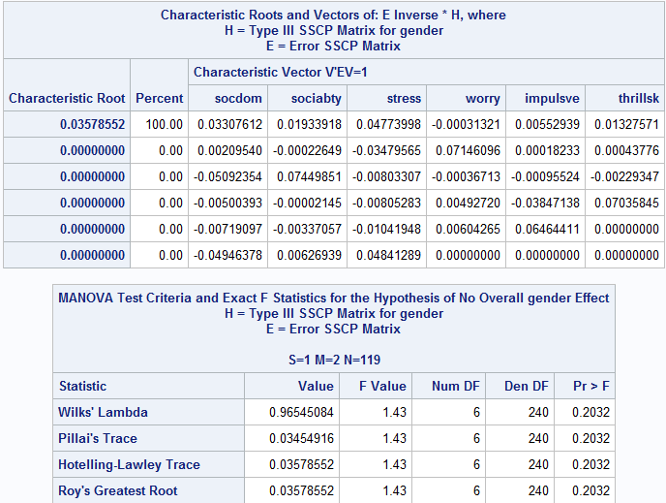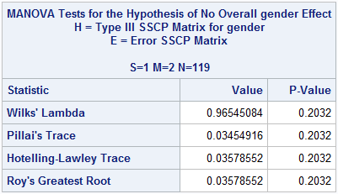

Appendix table 11E Inverse *H matrix for GRP and Exact p-value table for GRP (excluding interaction)

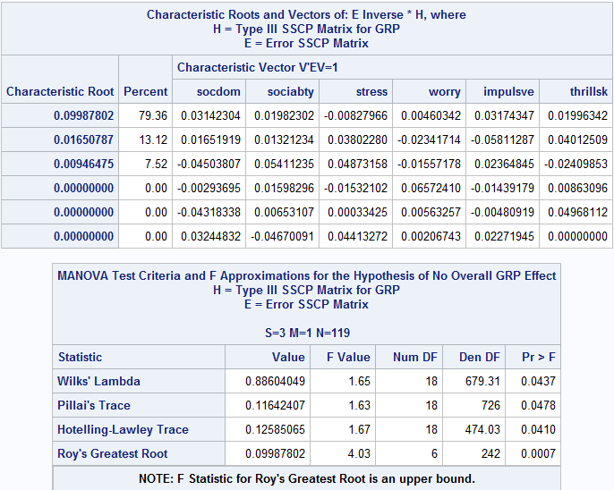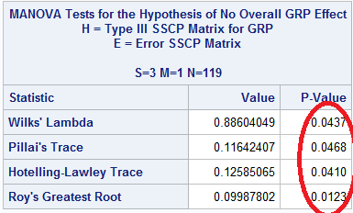

Appendix table 12 E Inverse *H matrix for GRP and Exact p-value table for GRP (One-way)

| **Characteristic Roots and Vectors of: E Inverse * H, where H = Type III SSCP Matrix for GRP E = Error SSCP Matrix** | | | | | | | |
| --- | --- | --- | --- | --- | --- | --- | --- |
| **Characteristic Root** | **Percent** | **Characteristic Vector  V'EV=1** | | | | | |
| **socdom** | **sociabty** | **stress** | **worry** | **impulsve** | **thrillsk** |
| **0.09702180** | 77.86 | 0.03045661 | 0.01974062 | -0.00980927 | 0.00457444 | 0.03210055 | 0.01967837 |
| **0.01726020** | 13.85 | 0.01188722 | 0.01913020 | 0.04401496 | -0.02444126 | -0.05391818 | 0.03643940 |
| **0.01032065** | 8.28 | -0.04418056 | 0.04979508 | 0.04485475 | -0.01080491 | 0.03175540 | -0.03002987 |
| **0.00000000** | 0.00 | -0.00094640 | 0.01369070 | -0.01651820 | 0.06630678 | -0.01404024 | 0.00864480 |
| **0.00000000** | 0.00 | 0.04108946 | -0.05038994 | 0.04004474 | 0.00126044 | 0.02333888 | -0.00708734 |
| **0.00000000** | 0.00 | -0.03830368 | 0.00019869 | 0.00842222 | 0.00587055 | -0.00123271 | 0.04882719 |

| **MANOVA Test Criteria and F Approximations for the Hypothesis of No Overall GRP Effect H = Type III SSCP Matrix for GRP E = Error SSCP Matrix S=3    M=1    N=119.5** | | | | | |
| --- | --- | --- | --- | --- | --- |
| **Statistic** | **Value** | **F Value** | **Num DF** | **Den DF** | **Pr > F** |
| **Wilks' Lambda** | 0.88693840 | 1.64 | 18 | 682.14 | 0.0451 |
| **Pillai's Trace** | 0.11562365 | 1.62 | 18 | 729 | 0.0488 |
| **Hotelling-Lawley Trace** | 0.12460265 | 1.66 | 18 | 476.03 | 0.0427 |
| **Roy's Greatest Root** | 0.09702180 | 3.93 | 6 | 243 | 0.0009 |
| **NOTE: F Statistic for Roy's Greatest Root is an upper bound.** | | | | | |

| **MANOVA Tests for the Hypothesis of No Overall GRP Effect H = Type III SSCP Matrix for GRP E = Error SSCP Matrix S=3    M=1    N=119.5** | | |
| --- | --- | --- |
| **Statistic** | **Value** | **P-Value** |
| **Wilks' Lambda** | 0.88693840 | 0.0451 |
| **Pillai's Trace** | 0.11562365 | 0.0478 |
| **Hotelling-Lawley Trace** | 0.12460265 | 0.0427 |
| **Roy's Greatest Root** | 0.09702180 | 0.0149 |

Appendix table 13 Tukey grouping for Social dominance, Sociability and Impulsivity

| **Means with the same letter are not significantly different.** | | | | | | | |
| --- | --- | --- | --- | --- | --- | --- | --- |
| **Tukey Grouping** | | **Mean** | | **N** | | **GRP** | |
|  | A | 0.3749 | | 37 | | 1 | |
|  | A |  | |  | |  | |
| B | A | 0.1462 | | 90 | | 3 | |
| B | A |  | |  | |  | |
| B | A | 0.1228 | | 87 | | 2 | |
| B |  |  | |  | |  | |
| B |  | -0.3447 | | 36 | | 4 | |
| **Means with the same letter are not significantly different.** | | | | | | | | |
| **Tukey Grouping** | | | **Mean** | | **N** | | **GRP** | |
|  | A | | 0.3957 | | 37 | | 1 | |
|  | A | |  | |  | |  | |
| B | A | | 0.1204 | | 90 | | 3 | |
| B | A | |  | |  | |  | |
| B | A | | 0.0064 | | 87 | | 2 | |
| B |  | |  | |  | |  | |
| B |  | | -0.3089 | | 36 | | 4 | |

| **Means with the same letter are not significantly different.** | | | | |
| --- | --- | --- | --- | --- |
| **Tukey Grouping** | | **Mean** | **N** | **GRP** |
|  | A | 0.4949 | 37 | 1 |
|  | A |  |  |  |
| B | A | 0.0714 | 87 | 2 |
| B |  |  |  |  |
| B |  | -0.0312 | 90 | 3 |
| B |  |  |  |  |
| B |  | -0.2386 | 36 | 4 |

Appendix table 14 for eigenvalue of the Correlation matrix and Rotated factor pattern

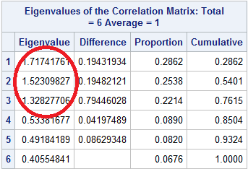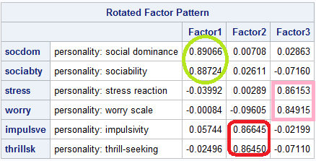

Appendix table 15, Pearson Correlation Coefficients and Mean vector of 3 factors by four age groups.

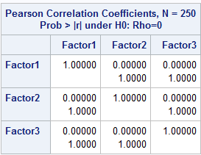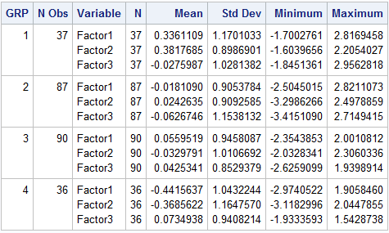

Appendix table 16 E Inverse *H matrix for GRP and Exact p-value table for GRP (factor analysis)

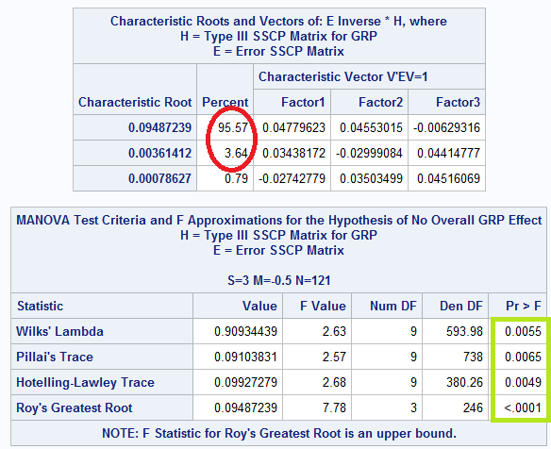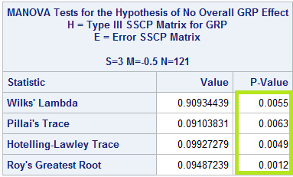

Appendix table 17 Tukey grouping for factor 1 and factor 2

For Factor 1:y1= personality: social dominance and y2= personality: sociability

